BSI Employee Website User Help / Guide
Boiler Services and Inspection, LLC | www.BoilerServicesAndInspection.com
Version 1.0
tyler chambers
2015
Contents
Purpose of this Document 2
Project Summary 2
Signing Up to the BSI Website 3
Downloading Past Reports 5
Locating the Download Manager 5
Using the Download Manager to Retrieve Past Reports 7
Once You Have Downloaded the Report 10
Uploading Your Current Report 11
Locating the Upload Manager 11
Before You Can Upload Your Report 14
Using the Upload Manager to Send Your Current Report/Additional Pictures 14
Support 17
Feedback 17
Appendix 18
How to Find a File You Downloaded 18
Extracting a Zipped Folder 19
How to Zip Files 20

Purpose of this Document

This document is intended to help users avoid problems when using the BSI Website to download past reports or upload current reports. Please follow the instructions laid out in this document in order to avoid any issues when using the website to download or upload files. Failure to follows these instructions could lead to issues using the website as it is intended.

Please note that that this project is a work in progress, and I certainly do not claim that it is perfect. When we run into issues, I will do my best to solve them as quickly and thoroughly as possible. Please bear with me as I may also be onsite at a mill performing data analysis with the TDS when problems occur. I will still do my best to assist with any problems and I want to encourage all of you to contact me if there are any issues that aren’t addressed in the following documents or in the help section of the website.

Project Summary

Over the last year, BSI has implemented an easier way for inspectors to retrieve reports from previous years and also to upload their reports straight to the BSI office. This was achieved by adding new sections to the BSI website (http://www.BoilerServicesAndInspection.com) where users can both download reports from previous years and upload their current report/additional pictures straight to the website. We hope that this will replace the need to request the old reports from the BSI office by allowing you to browse and download the reports directly to your computer. This should also replace the need for you to mail the reports on USB flash drives by allowing you to directly send your current report and additional pictures to the BSI office from the website.

The following sections of this document will provide instructions on how to sign in to the website, how to download past reports, and how to upload your current report. Using your feedback, I will change/update this document as needed and provide a place on the website for you to download the latest version as new issues arise and old issues are resolved. You will find my contact information at the end of this document in case you run into any issues signing up to the website, downloading or uploading files.

Signing Up to the BSI Website

Signing up to the website is the first step before a user can use the new sections to download and upload reports from the website. This step must be completed first in order to use the Employee section of the website.
To sign up to the website, follow the instructions below:
- Open a web browser (such as Internet Explorer, Google Chrome, or Mozilla Firefox) and navigate to the BSI website (http://www.BoilerServicesAndInspection.com) 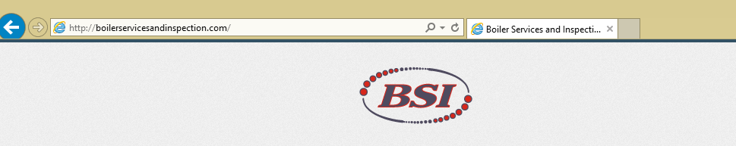
- Click on the red button labeled “Employee Login” at the top right of the page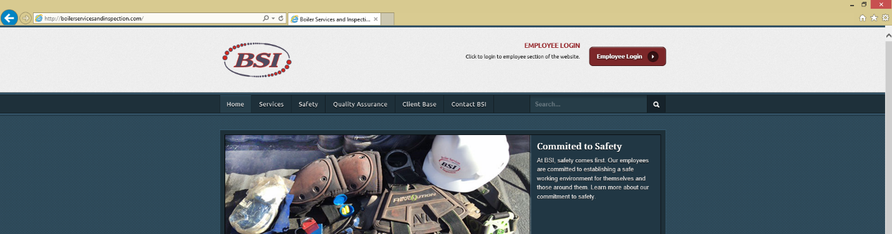
- You will be redirected to the same sign-in page that you used to sign in to your @bsimail.com email address. On this page, you will enter your BSI email address (your first initial, last name, @bsimail.com, i.e. tchambers@bsimail.com) and the password that you set up for your BSI Email address. Please note that I do not know your password and do not have access to them. If you can’t remember your password, I can reset it for you, but it will be up to you to set it again and remember it.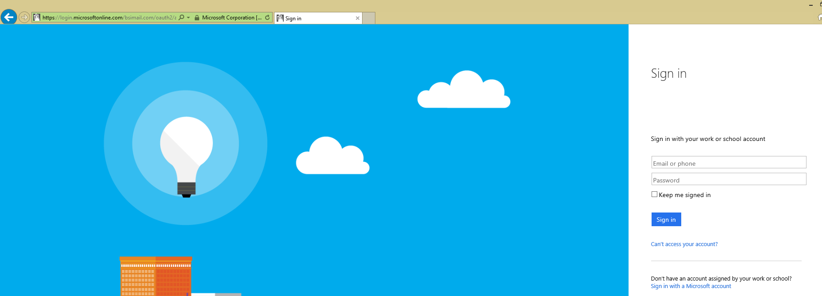
- You will be logged into the site and redirected back to the BSI website Employee Section once you have logged in. 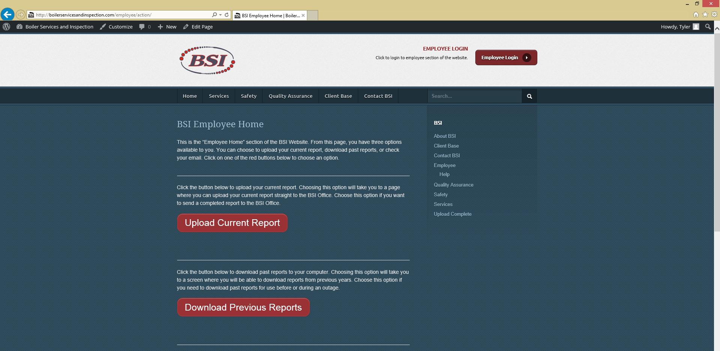

If you are unable to complete this process, please contact Tyler Chambers by emailing tchambers@bsimail.com and please be as specific as possible when explaining your problem.

Downloading Past Reports

The first new feature of the website gives the users the ability to browse and download past reports. This section of the website is intended to allow users to find and download reports from up to two years back (we may allow more years in the future if needed) on their own without the need to request the reports from the BSI office. Having the past reports available at any time will make the process of getting past reports much easier by allowing users to retrieve them any time they have an Internet connection.
Please note that you must be connected to the internet in order to browse to the website, download, and upload files. This process will not work without an active connection to the internet.

Locating the Download Manager

Follow the steps below to find the download manager – which is used to download past reports to your computer.
In order to use this part of the website, you must have completed the first part of these instructions entitled “Signing up to the BSI Website”.
- Open a web browser (such as Internet Explorer, Google Chrome, or Mozilla Firefox) and navigate to the BSI website (http://www.BoilerServicesAndInspection.com)
- Click on the red button labeled “Employee Login” at the top right of the page

- If you have not signed up for the BSI Website, please follow the instructions in the first section of this document in order to use this part of the website. If you are connecting from a new computer, or have been logged out, you will have to sign in again. Just like when you signed up, you will enter your BSI email address (your first initial, last name, @bsimail.com, i.e. tchambers@bsimail.com) and the password that you set up for your BSI Email address. Please note that I do not know your password and do not have access to them. If you can’t remember your password, I can reset it for you, but it will be up to you to set it again and remember it.
- You will be logged into the site and redirected back to the BSI website Employee Section once you have logged in. If you were already logged in, you will be brought straight to this page after clicking the “Employee Login” button on the homepage.
Once on this page, you will click the red button that says “Download Past Reports.”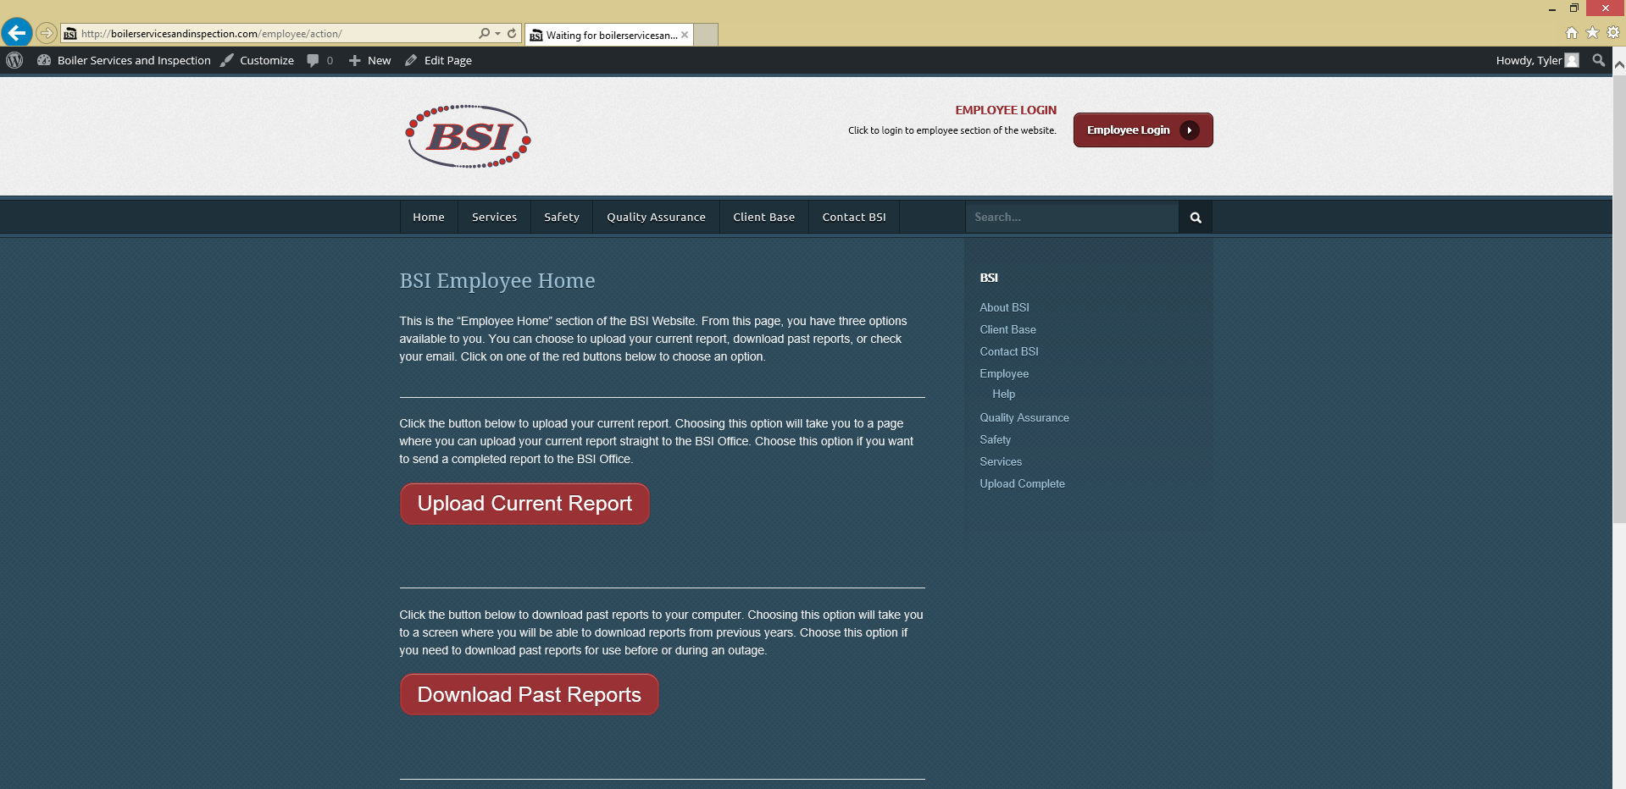

- You will now be at the download page. On this page, there are instructions on how to download as well as some tips. Please make note of these if you run into any issues.
Below these instructions you will see the “Download Manager.” This is where you will actually download the past reports to your own computer.

Using the Download Manager to Retrieve Past Reports

Once you have located the download manager, you can begin the process of downloading the past report(s) that you need by following the instructions below:
- Choose the year you wish to retrieve the report from by clicking on that year in the Download Manager.

- Choose the company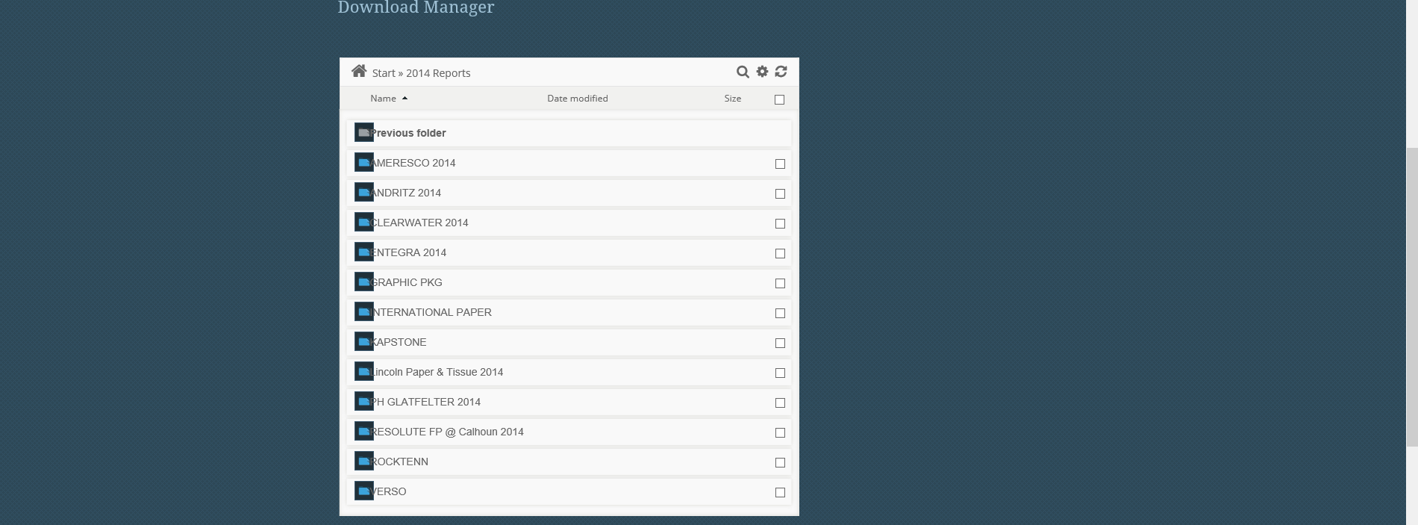
If you selected the wrong year, and need to go back, simply click the “Previous Folder” option in the download manager.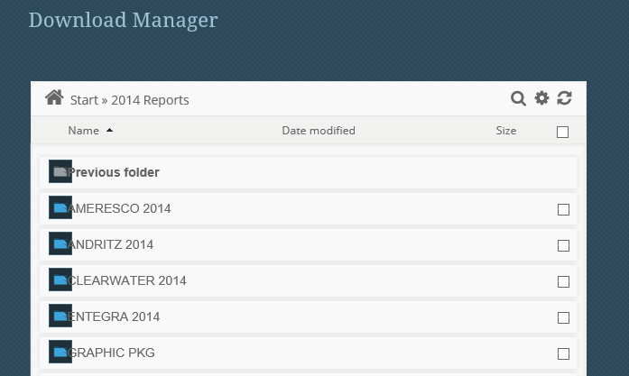

- If the company has more than one location in the folder, you will have to select the location next (i.e. International Paper)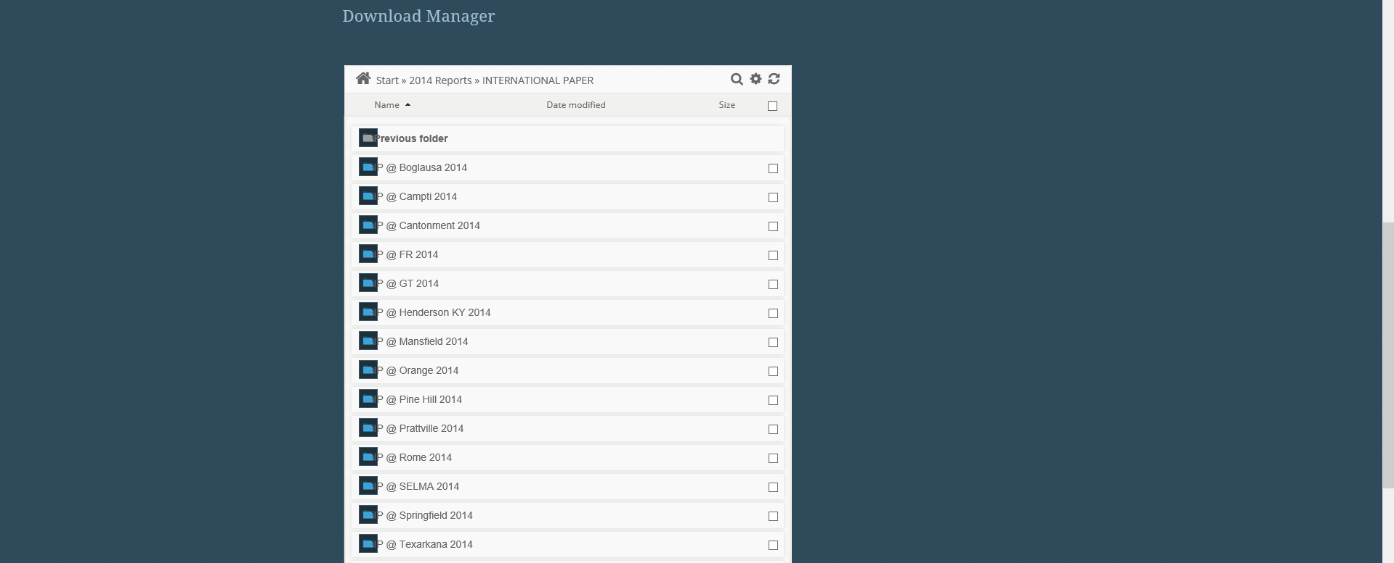
- Then, you will select the boiler/report you wish to download.
- Your download will begin automatically, or you may be presented with a popup box asking you what to do with the file. If you are presented with the popup box, always choose “Save As”.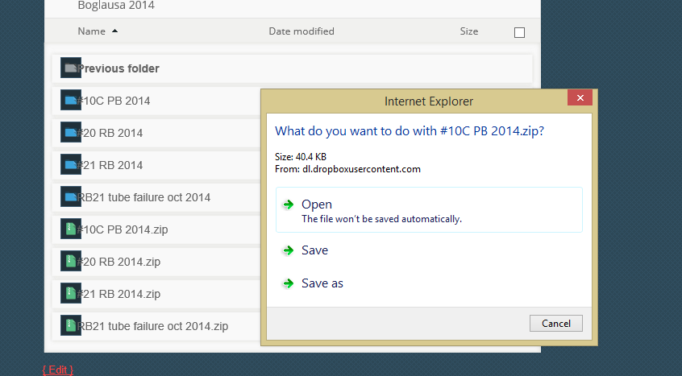
- This will open up a dialog box allowing you to choose where to save the file. Pick a location that YOU WILL REMEMBER. The default location is in the “downloads” folder. Once you choose a location, hit “Save” to download the file.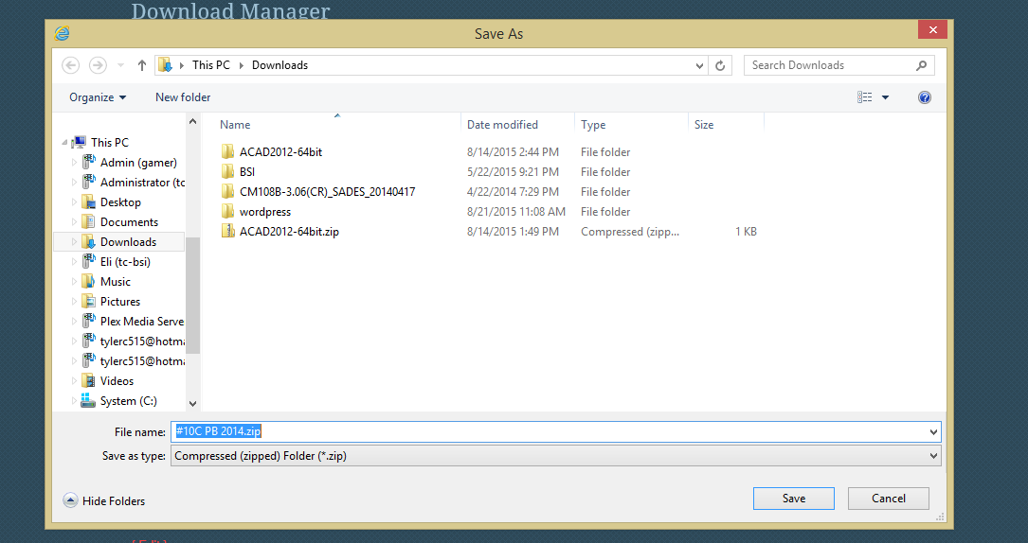
You can choose a different location from this list, but it is important to remember the location you choose.

Once You Have Downloaded the Report

If you don’t remember where you downloaded the file, or you are having trouble locating the file you downloaded, please see How to Find a File You Downloaded in the Appendix.
Once you find the file, you will see that it was downloaded in zip (.zip) format. In order to open the report, you will first have to unzip the folder. If you do not know how to unzip a folder, please see Extracting a Zipped Folder in the Appendix.

Uploading Your Current Report

The second new feature on the BSI Website is the ability to use the Employee section to directly upload (send) your completed report and additional pictures straight to the BSI Office. This will hopefully eliminate the need to send in USB flash drives with the reports and additional photos and allow inspectors to upload their reports with ease for immediate access by the BSI Office.

Locating the Upload Manager

Follow the steps below to find the Upload Manager – which is used to upload your current report straight to the BSI Office.
In order to use this part of the website, you must have completed the instructions in the first section of this document, titled “Signing up to the BSI Website”.
- Open a web browser (such as Internet Explorer, Google Chrome, or Mozilla Firefox) and navigate to the BSI website (http://www.BoilerServicesAndInspection.com)
- Click on the red button labeled “Employee Login” at the top right of the page

- If you have not signed up for the BSI Website, please follow the instructions in the first section of this document in order to use this part of the website. If you are connecting from a new computer, or have been logged out, you will have to sign in again. Just like when you signed up, you will enter your BSI email address (your first initial, last name, @bsimail.com, i.e. tchambers@bsimail.com) and the password that you set up for your BSI Email address. Please note that I do not know your password and do not have access to them. If you can’t remember your password, I can reset it for you, but it will be up to you to set it again and remember it.
- You will be logged into the site and redirected back to the BSI website Employee Section once you have logged in. If you were already logged in, you will be brought straight to this page after clicking the “Employee Login” button on the homepage.
Once on this page, you will click the red button that says “Upload Current Report.”

- You will now be at the Upload page. On this page, there are instructions on how to upload your current report as well as some tips. Please make note of these if you run into any issues.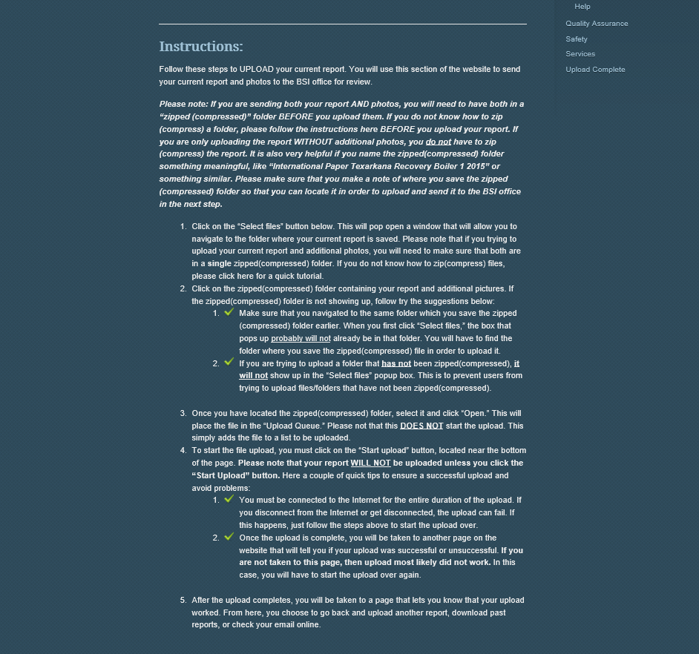
Below these instructions, you will see the “Upload Manager.” This is the tool you will use to send your current report and additional pictures to the BSI office.

Before You Can Upload Your Report

Before you can upload your current report and pictures, the files must be zipped(compressed). If you do not know how to zip files, please see How to Zip Files in the Appendix.

Using the Upload Manager to Send Your Current Report/Additional Pictures

Once you have located the Upload Manager, you can begin the process of uploading your current report(s) that you need by following the instructions below:
- Click the “Select files” button to open a dialog box that will allow you to select which report you want to upload.
- Navigate to the folder where you saved your report in zip format (if you do not know how to save the report and pictures in zip format, please see How to Zip Files in the Appendix). Select the zipped folder and click the “Open” button.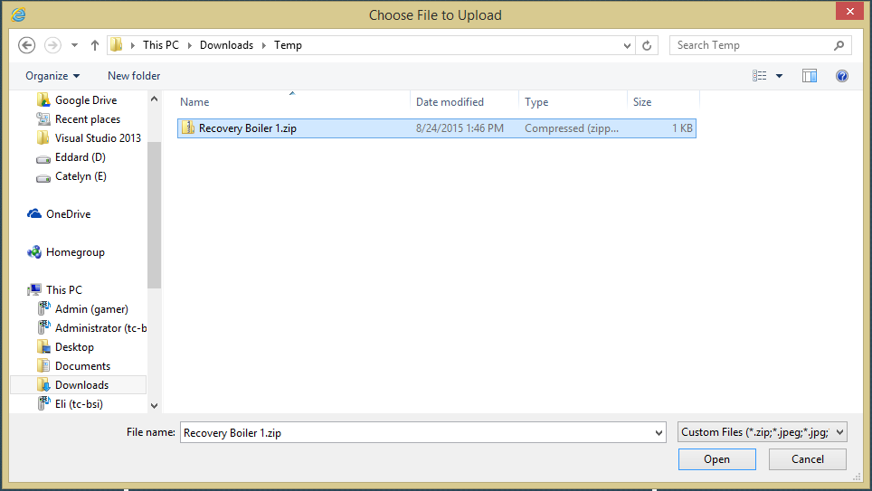
Choose the file you want to upload, then click the “Open” button.

- The report is now added to the “Upload Queue.” Please note that this does not start the file upload process. This gets the file ready to upload.
YOU MUST CLICK THE “START UPLOAD” BUTTON IN ORDER TO UPLOAD THE FILE!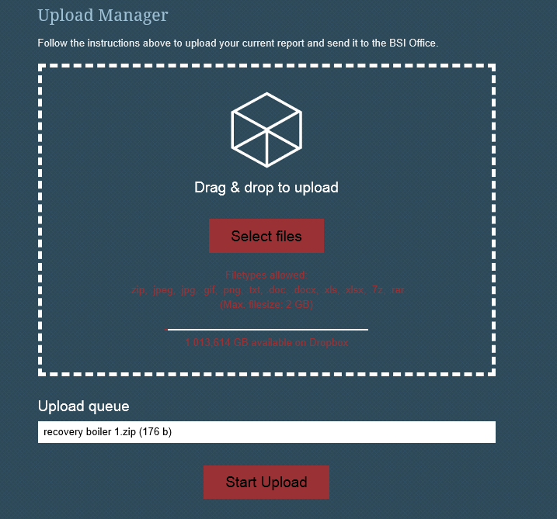
You can see that the file has been added to the “Upload Queue,” but to start the upload, you MUST click the “Start Upload” Button.

- Once the file has begun uploading, you will be taken to a screen that looks like this: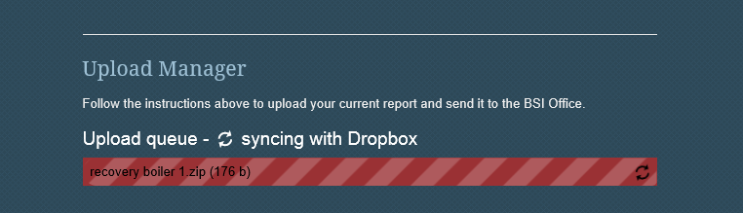
After the upload is complete, you will be taken to a screen that tells if you the upload was successful or if the upload failed. A successful upload will look like this:
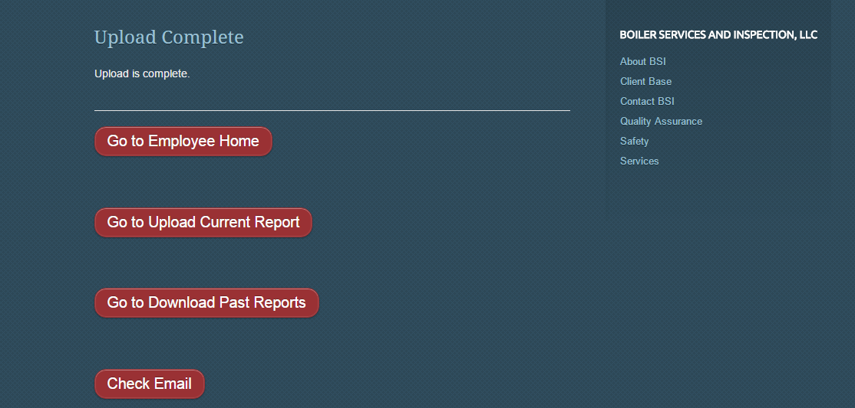

An email will be sent to the BSI Office to let them know that you have uploaded a report. Please keep in mind that it is very helpful to name your files something meaningful and descriptive. Please include the mill name, boiler name, and year at the very least.

Support

This portion of the BSI website has been tested and is working as it should for me; however, that does not mean that we will not have issues in the field. If you have issues that cannot be resolved by using this document or the help listed on the website, please don’t hesitate to contact me. My contact information is listed below:

Tyler Chambers
Email: tchambers@bsimail.com
Phone: (870) 224-1938

Feedback

If you would like to make suggestions as to how I could make the experience better for you, please email tchambers@bsimail.com.

Appendix

How to Find a File You Downloaded

If you cannot find the file you downloaded, you can follow these instructions:
When you use Internet Explorer to download a file from the Internet, you are usually asked where you want to store the file. If you don't specify where you want the file to be stored, Internet Explorer will normally try to put a file in the most appropriate place. For example, documents and webpages are normally saved to the Documents folder, music files to the Music folder, and images and graphics are saved to the Pictures folder. In Internet Explorer 7, files that could potentially cause harm, such as executable programs, are saved to the temporary Internet files folder first, then copied to the folder you've specified. Programs and miscellaneous downloads are also sometimes saved to the Downloads folder. Here are some tips on finding files you've downloaded.
If you're downloading a file and the Save File dialog box appears, it is best to specify which folder you want to save the file to. This will save time later. If you're saving several files, Windows will normally remember the last folder you saved to, so you don't have to specify the folder again.
To find a file you have downloaded
- Open your personal folder by clicking the Start button , and then clicking your user name at the top of the Start menu's right pane.
- Double-click one of the following folders:
  - Downloads
  - Documents
  - Pictures
  - Videos
  - Music
If you do not see the file you are looking for, but know its file name, you can search for it by following these steps:
To search for a file you have downloaded
- Click the Start button .
- Type all or part of the file name into the Search box. The file you are looking for should appear in the list of search results. If the file you are searching for does not appear, see Troubleshoot problems with searching.

Extracting a Zipped Folder

Before you can open the report you just downloaded, you will have to unzip the folder you just downloaded. To unzip a folder, follow these instructions:
To extract (or unzip) files or folders from a compressed folder
- Locate the compressed folder that you want to extract files or folders from.
- Do one of the following:
  - To extract a single file or folder, double-click the compressed folder to open it. Then, drag the file or folder from the compressed folder to a new location.
  - To extract the entire contents of the compressed folder, right-click the folder, click Extract All, and then follow the instructions.

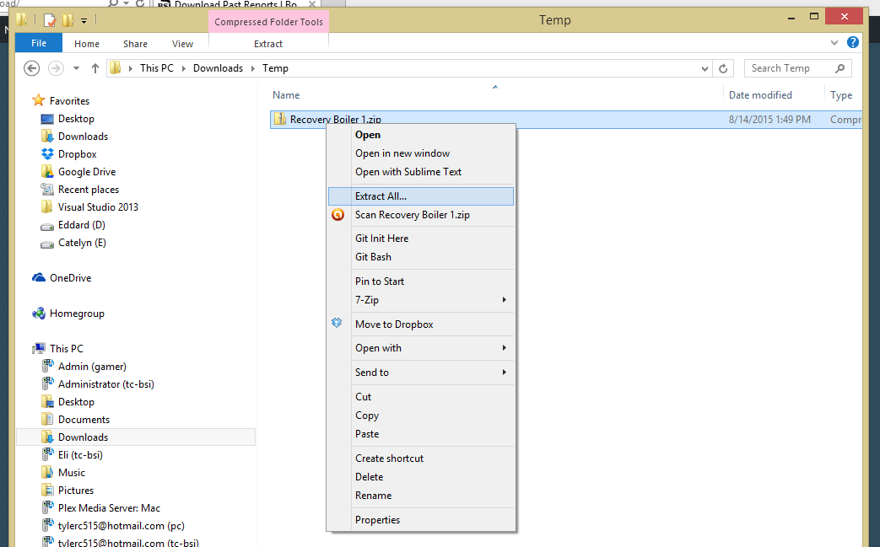

How to Zip Files

Before you can upload your report and photos to the BSI office, the files must be zipped. Follow the instructions below to learn how to zip files. If you already know how to zip files and your report is already zipped, you can skip this section and proceed to the next section.
To compress (or zip) a file or folder:
- Locate the file or folder that you want to compress.
- Right-click the file or folder, point to Send to, and then click Compressed (zipped) folder.
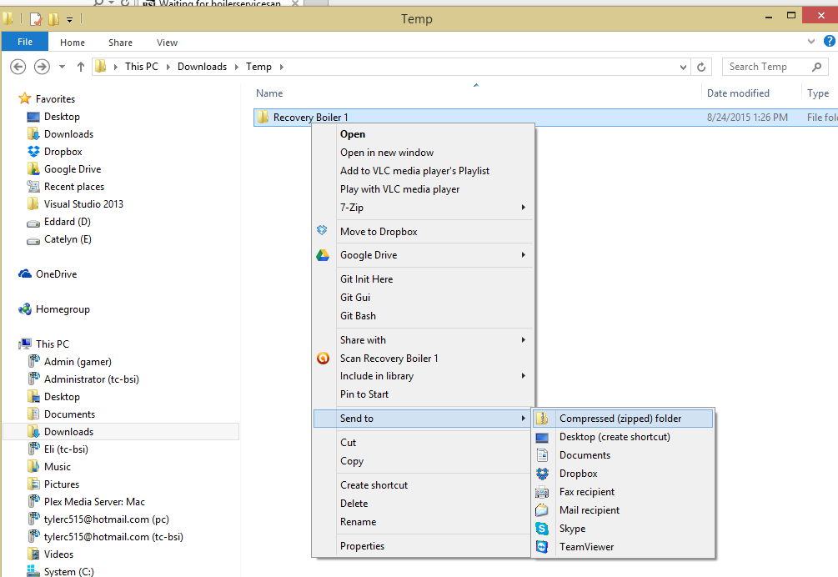
A new compressed folder is created in the same location. To rename it, right-click the folder, click Rename, and then type the new name.

